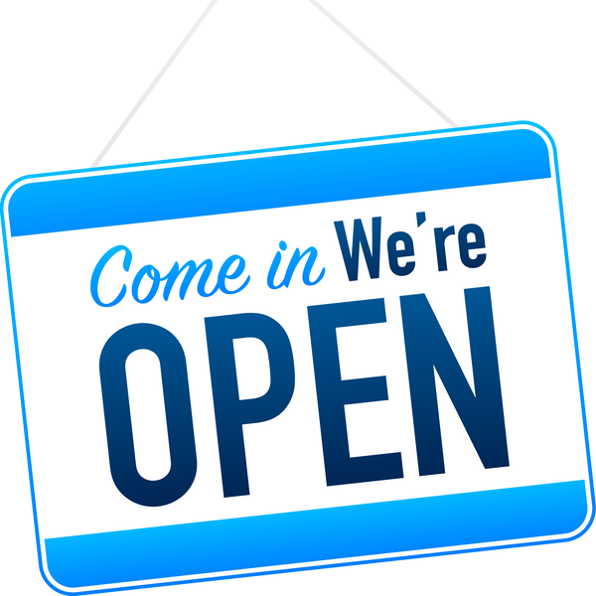

WAXA LAGUGU MARIQAADAY!

BARNAAMIJKA ADEEGA CUNTADA

IYO NAFAQADA EE ASBUUCA SHAQAALEYSIINTA

KAALAY IN

ARBACADA

8:00 AM - 2:00 PM

Xarunta Nafaqeynta Ardayda

14270 E. Briarwood Ave Centennial, CO 80112

Waraysi markiiba ah

Hadii Aadan Imaan Karin Arbacada?

Looma baahna is diyaarin,

Na soo Wac Waxaan Kuu Heli Karnaa Balan Maalin Kale

(720) 886-7139

Si fudud u soo gal

Boosaska la heli karo isla markiiba:

Maareeyaha jikada,kalkaaliye,shaqaalaha jikada iyo shaqaalaha gargaarka

Sawir QR-kan si aad u hesho macluumaad dheeraad ah iyo si aad shaqo u codsato!

Machadkan wuxuu bixiyaa fursado loo siman yahay

HADA ILAA DECEMBER 15keeda, 2021