**I HAVE A DREAM PROJECT**

On August 28, 1963, some 100 years after President Abraham Lincoln signed the Emancipation Proclamation freeing slaves, Dr. Martin Luther King, Jr. climbed the steps of the Lincoln Memorial to share his vision of the United States. More than 200,000 people – of every race and creed – came to listen. They came to Washington, D.C. to demand equal rights. The dream that they heard on the steps of the Monument became the dream of a generation. Dr. Martin Luther King’s strong belief in non-violent protest helped set the tone of the civil rights movement and influenced the passage of the Civil Rights Act of 1964, which outlawed discrimination on the basis of race, color, religion, sex, or national origin, required equal access to public places and employment, and enforced desegregation of schools and the right to vote.

Dr. Martin Luther King’s speech stated, in part:

**Let us not wallow in the valley of despair. I say to you, my friends, we have the difficulties of today and tomorrow.**

**I still have a dream. It is a dream deeply rooted in the American dream.**

**I have a dream that one day this nation will rise up and live out the true meaning of its creed. We hold these truths to be self-evident that all men are created equal.**

In celebration of Dr. Martin Luther King, Jr. Day, please have your child complete the attached activity. We would love to hear what your child’s dream is and how that dream can help bring about positive change in their community. Please have your child write down their dream, attach a picture of themselves to the photo frame, and include their name. The dreams will be displayed throughout Belleview’s school lobby. Please return it to school no later than **Friday,** **January 14, 2022.**

We also encourage you to read the complete “I Have a Dream” speech with your child. Thank you for your participation!

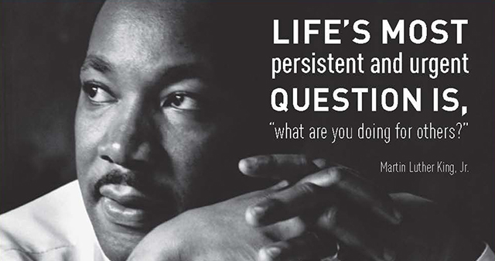

**I Have a Dream…**

