**Parent’s Guide to Schoology – Allowing teachers to send you e-mail messages.**

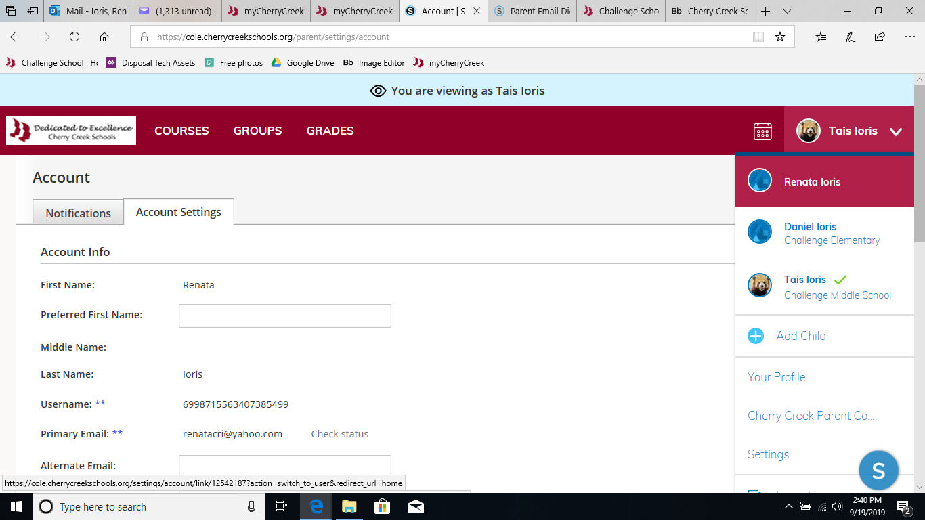

**2**

**1**

1 – Click on the name on the top right corner.

2 – Make sure you click on the parent name.

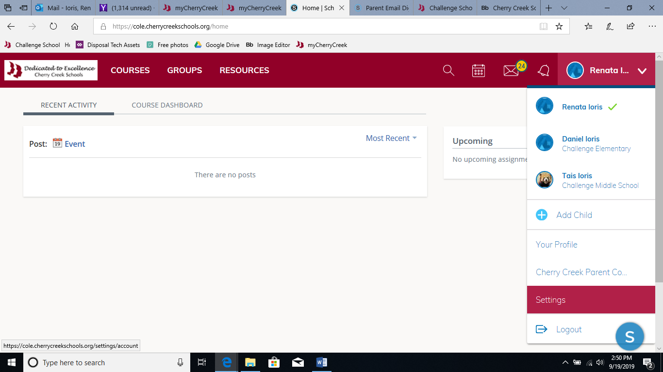

**3**

3 – Once you make sure the parent’s name is on the top right corner, click on “settings.”

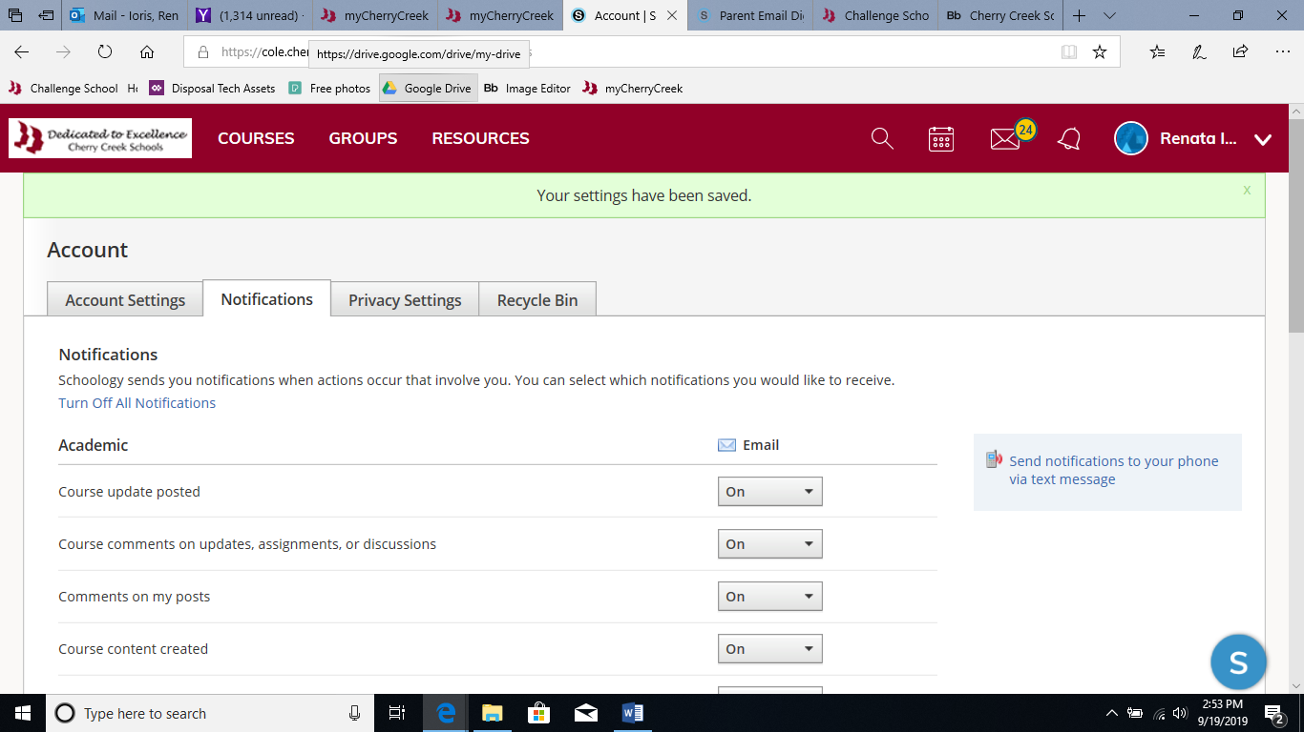

5

**4**

4 – In account settings, make sure you are on the “notifications” tab.

5 – Turn on notifications you would like to receive.

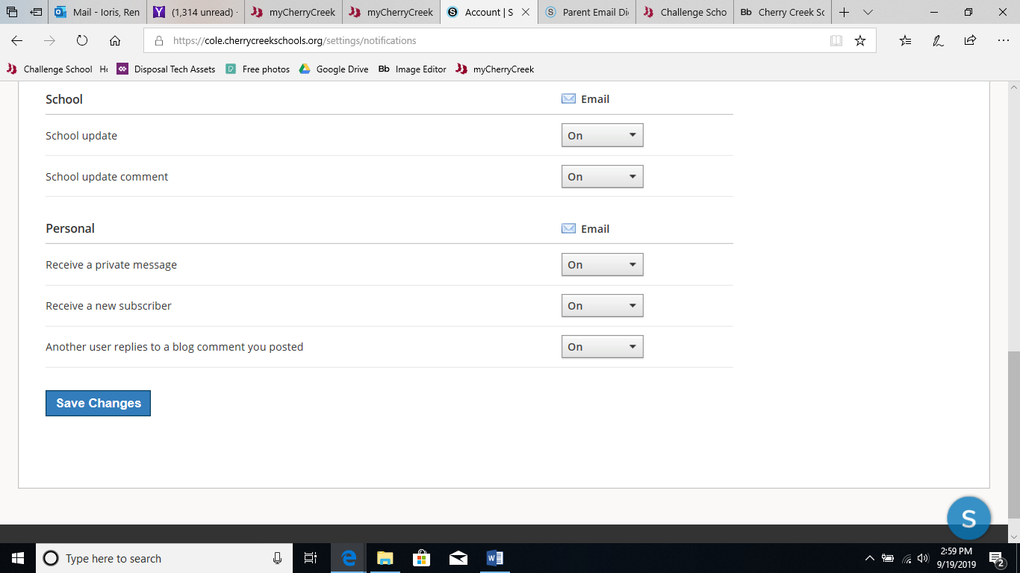

6

6 – Enable the “Receive a private message” to receive e-mails from the teachers.