|  |  |
| --- | --- |
| **AALADA MARINKA-TEAMS – OO LAGA SOO ISTICMAALAYO GURIGA**  Nidaamyada Macluumaadka  Tilmaamaha & Hagida Qaabka |  |

Microsoft Teams waa barxad barasho casriyeysan oo onlayn ah oo ardaydu kula xiriiri karaan macalimiinta ayna iskaashi la yeelan karaan asxaabtooda. Ardaydu waxay toos ula macaamili karaan macalimiintooda iyagoo isticmaalaya Microsoft Teams. barnaamijku waxaa loo isticmaali karaa wada hadalka fasalka, wax isdhaafsiga, wadahadalka fiidiyowga, iyo shirarka fasalada. Microsoft Teams waxaa laga soo isticmaali karaa kombuyuutarada iyo talafoonada gacanta.

**Sida loo helo loona rakibo Barnaamijka MS Teams**  
  
 MS Teams waxaa lagu isticmaali karaa internetka adiga oo adeegsanaya biraawsarkaaga ama adoo ku rakibaya codsiga isticmaalka kombiyuutarkaaga.

**Nidaamyada Macluumaadka waxay si adag ugu talinayaan in lagu rakibo ama aad gashato isticmaalka maxaa yeelay waxay ku siin kartaa Nidaam la isku halayn karo.**

**1) Ku bilow furitaanka nooca khadka tooska ah:**

* Gal  [my.cherrycreekschools.org](http://my.cherrycreekschools.org/)
* Ku soo gal e-maylkaaga CCSD iyo baasworka gaarka ah.
* Meesha hoose ee Taabka **MyProductivity** , Riix **Microsoft Teams** :

[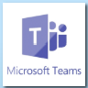](https://helpdesk.cherrycreekschools.org/api/v3/mojo_files/91766)

* Nooca khadka tooska ah ee MS Teams wuxuu ka furmi doonaa daaqad cusub oo biraawsar ah, waxaa laga yaabaa in lagu waydiiyo inaad mar labaad isticmaasho Aqoonsigaaga CCSD iyo Password-kaaga si aad ugu soo gasho Office 365.

**2) Soo dejiso oo rakib Codsiga-shaqsiga Macaamiisha:**

* • Ka dib markaad furto nooca khadka tooska ah ee Teams, si aad u rakibto isticmaalka macmiilka ee Teams, Riix oo **Soo Dejiso Desktopka Aabka**  geeska bidix ee hoose ee daruushada Teams:

[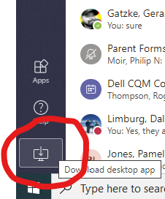](https://helpdesk.cherrycreekschools.org/api/v3/mojo_files/91773)

* Rakibayaasha Teamska waxay ku soo gali doonaan kombuyuutarkaaga, Riix calaamada **'Teams_windows_x64.ex'** oo ka muuqan doonta bidixda hoose ee daaqada biraawsarka:

[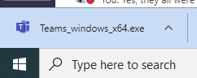](https://helpdesk.cherrycreekschools.org/api/v3/mojo_files/91776)

* Raac tilmaamaha macmiilku si uu u rakibmo. Marka la dhameeyo, astaamaha Teamska waxay ka muuqan doonaan **Bilowga Menu:**

**3) Ku bilow barnaamijka Teams desktopka:**

* Laga soo bilaabo dhinaca Menu 
* Riix calaamada Microsoft Teams si aad u bilowdo isticmaalka:

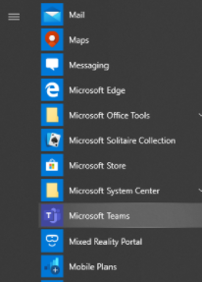

**Macluumaad:**

* Maqaalada Aqoonta ee ku saabsanTeamska - <https://helpdesk.cherrycreekschools.org/help/topic/261793>